

Structural Design

(Inside View)

**Vertical corrugation**

Design#:

67*/*16

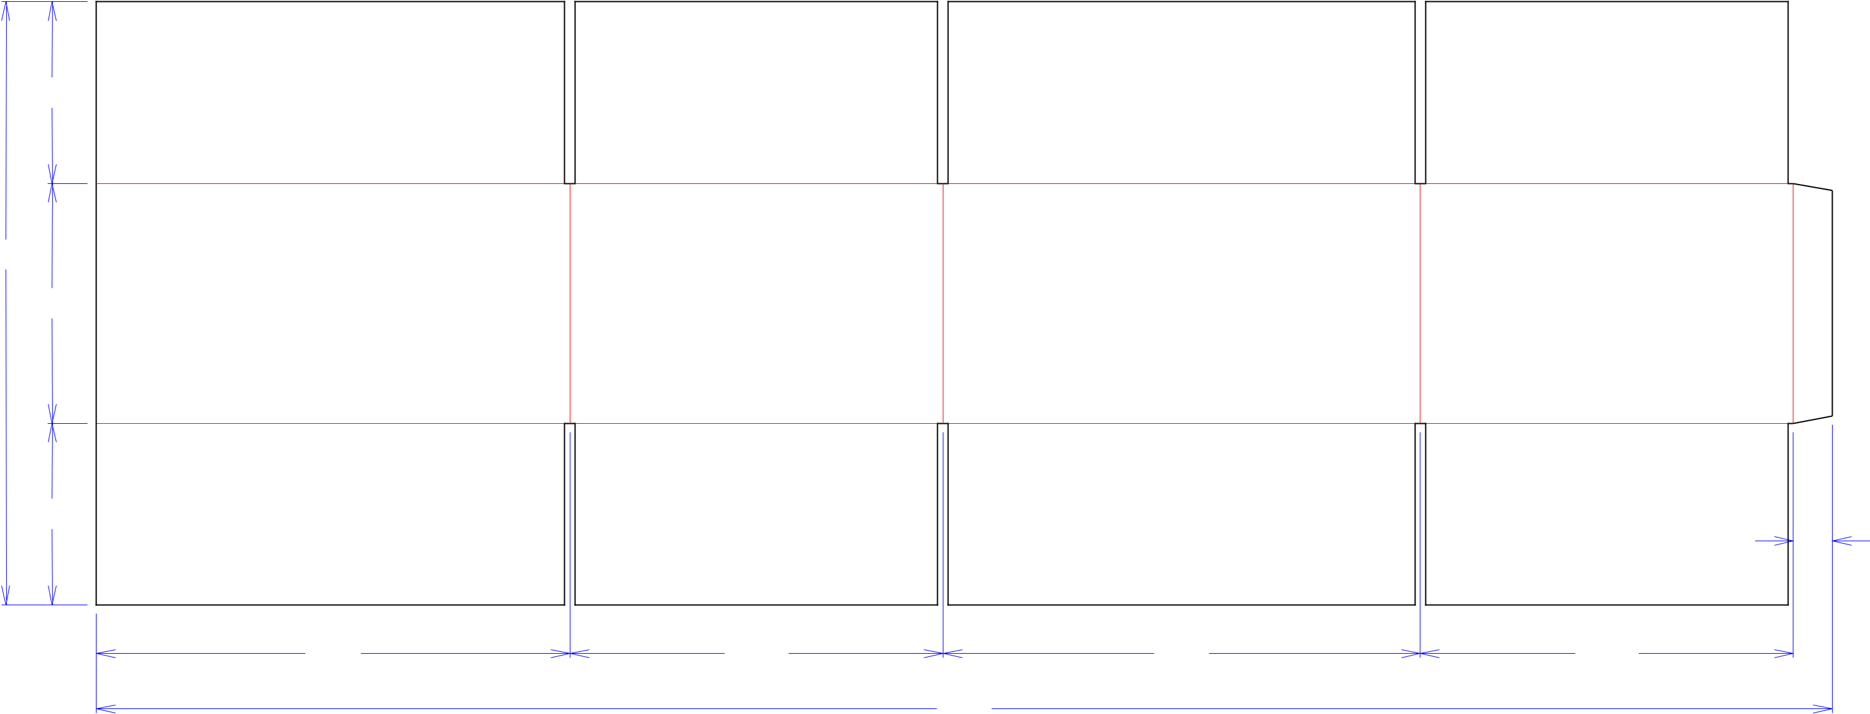

213*/*8

81*/*2

|  |  |  |  |  |
| --- | --- | --- | --- | --- |
| 67*/*16 |  |  | 13*/*8 |  |
|  |  |  |  |
| 163*/*4 | 133*/*16 | 167*/*8 | 133*/*16 |  |
|  |  | 613*/*8 |  |  |

**160692-01_B**

Customer:

**DeMet's Candy**

Description:

**6CT case of caddies: Turtles Caddy 24ct 4pc bar [Lefthand 1/8"gap]**

**SINGLE-OUT DRAWING**

Qty/Unit:

Style: **RSC**

Board: **44BK**

Combination: **42 - 36M - 42**

I.D. : **16+3/4 x 13+1/16 x 8+1/4**

Area of Blank - Waste : **8.87 sq. ft.**

Waste on Blank : **2.66%**

Finished Piece Weight: **1.19 lbs./541.16g**

Over-all Blank: **21+3/8 x 61+3/8**

Notes:

**Caddies on back 3x2x1high**

Revision Info: **[B] 10/17/2016**

Designer: **Alan Groff**

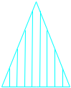

Cut Crease Crease with Matrix Cut Crease Half Knife Cut Tear Tape Perforation



Designright and Copyright of DS Smith Corrugated Packaging Ltd. This technical Specification is subject to Manufacturing tolerances. Drawing dimensions shown are crease to crease. Date printed: 01/17/2019